**Teaching Assistant Exercises for 17/9/19**

**Gadtardi Wongkaren 2301929480**

**Exercise 1**

**Programming:**

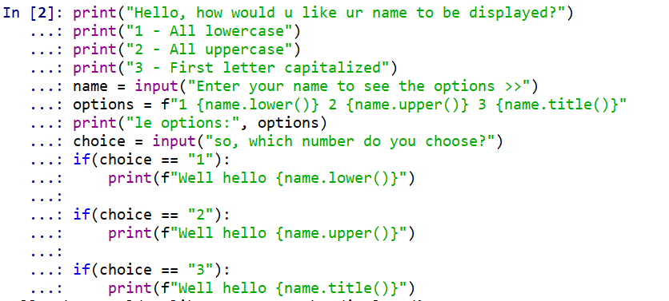

**Result:**

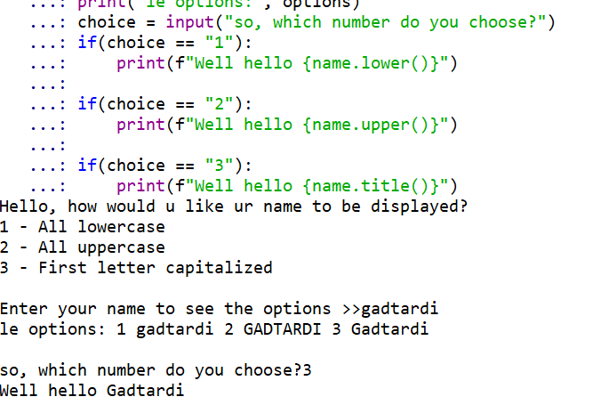

**Exercise 2**

**Programming:**

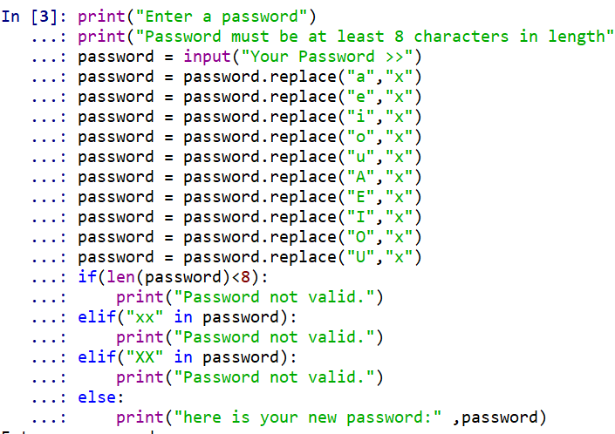

**Result:**

